**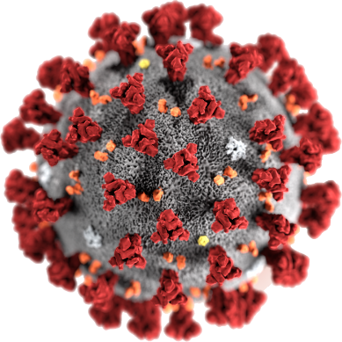****COVID - 19**

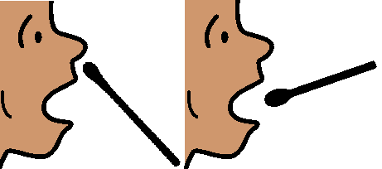

**You have had a test.**

**You must go home**

**Wait at home. Do not go out.**



**Wait to hear what to do next.**

Based on the Victorian and Queensland Premiers Press conferences 30 July 2020.

Developed by Access Easy English. Australia. 30 July 2020. Images from Freepikpsd, InspiredServices, Mayer-Johnson, Picto-Selector