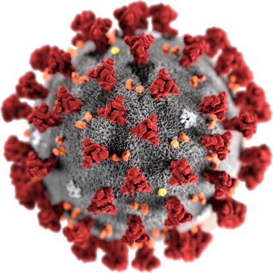

COVID - 19

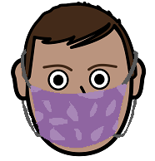
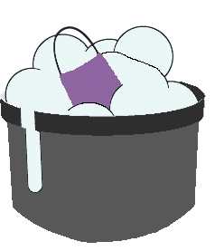

How to use a mask.
Wash it. Use it again.
19 July 2020

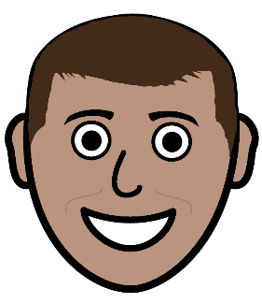
Put on a mask

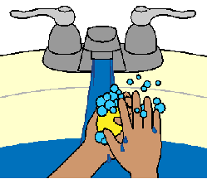

- Wash your hands.

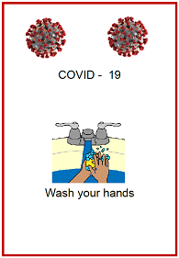
Read the fact sheet
Wash your hands.

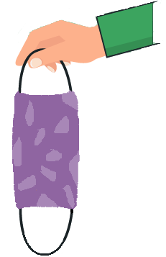
- Pick up a new mask.

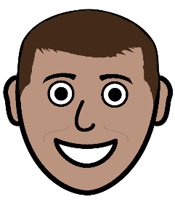
There is an inside. It goes on your face.

There is an out side. You can see the colour.

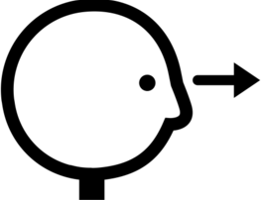
Look at the mask.
There must be no holes in it.
It must be clean.

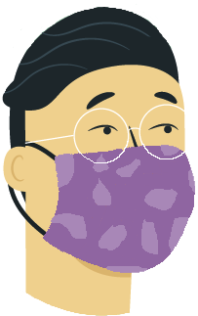
- Put the mask on your face.
Put the loops around each ear.

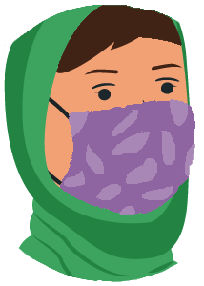
- There must be no gaps between
- your face
- the mask.
Move your mask so there are no gaps.

- You need to check your mask covers
- your nose
- your mouth.

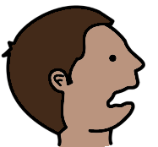

The bottom of your mask goes under your chin.
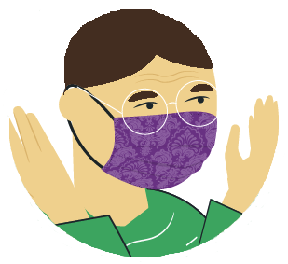
- You are ready to go out.
Do not touch your mask now.

Get the poster. Put it on the wall in
- bathroom
- kitchen
- bedroom
- near the front door.
Take off your mask

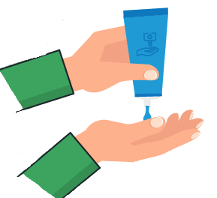

- Wash your hands.

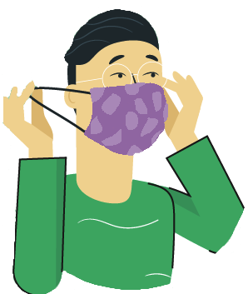

- Do not touch the front of your mask.

- Hold on to the loops behind your ears.
Take the loops off your ears.
Your mask comes off your face.
- Hold onto an ear loop.
Do not touch the front of your mask.

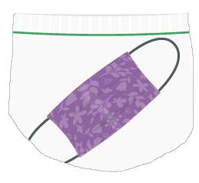
- Put the mask in a plastic bag.
The bag needs to seal across the top.

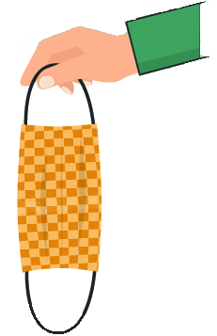

- You need a new mask for next time.

- Wash your hands
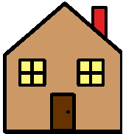
When you get home

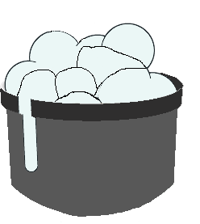
5. Get a tub
- with soap
- with hot water.

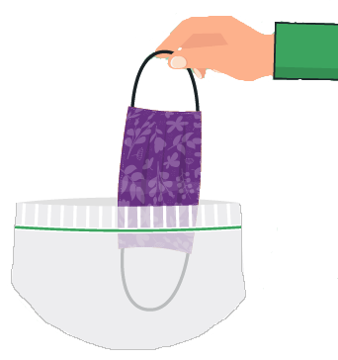
6. Take the dirty mask out of its bag.
Hold on to the loops only.

- Put the mask in the water.
Wash the mask.

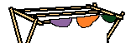
- Hang the mask to dry.

- Wash your hands.

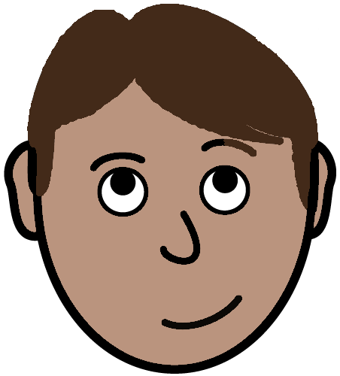
To be safe.
Some things to remember

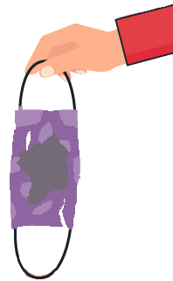
- A mask may get
- wet
- ripped.

It is no good.

You need a new mask.
- Your mask must fit.

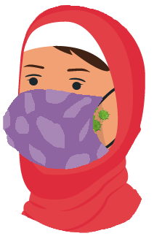

There must be no gaps. It is no good now.

- You mask needs to cover your
- mouth
- nose.

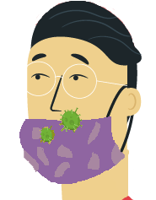

Do not let it fall down. It is no good now.

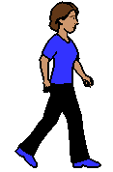
- We must have space between us.

Some times we do need to stand near people. Like at the shops.
Leave your mask on.

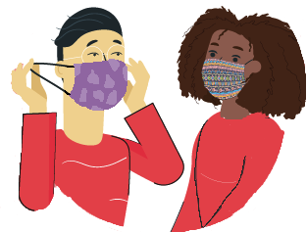

Do not take your mask off here.

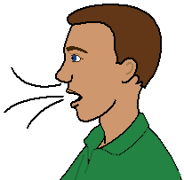
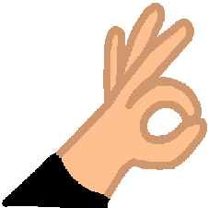
- You do need to be able to breath with your mask on. You need to feel OK.

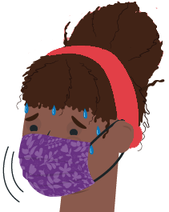
You may find it hard to breathe.
Do not wear your mask.

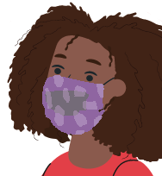
- Your mask may get
- wet
- torn
- dirty.

You need a new mask.
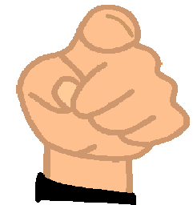
- Your mask is for you.

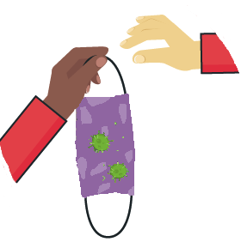
Do not give it to some one else to wear.

Images
We have used images from
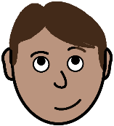
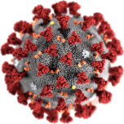
- EasyOnTheI
- Freepikpsd
- Mayer-Johnson
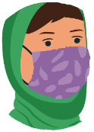
- Picto-Selector
- World Health Organisation.

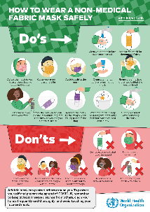
This fact sheet is based on The World Health Organisation How to wear a medical mask safely. www.who.int/epi-win 17 July 2020

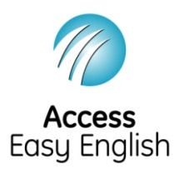
Access Easy English wrote the Easy English.
21 July 2020.

