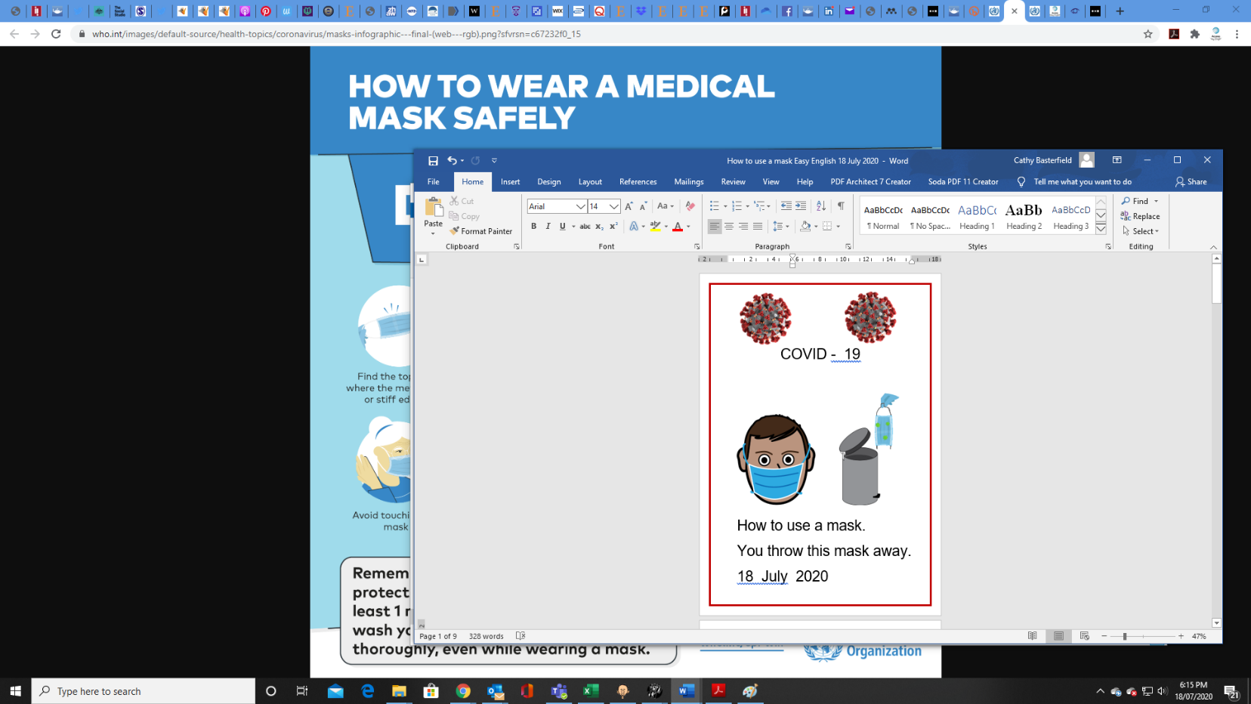

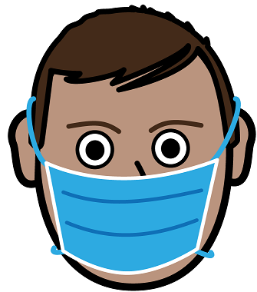

Read the fact sheet

**How to put on a mask How to put on a mask**

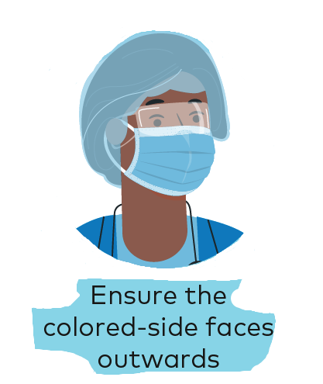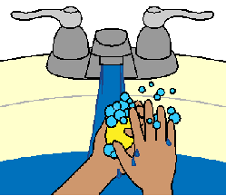

1. 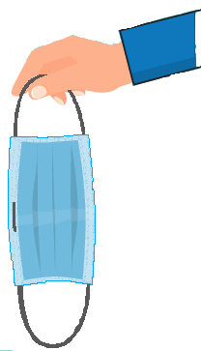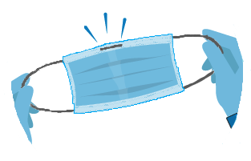 **2. 3. 4.**

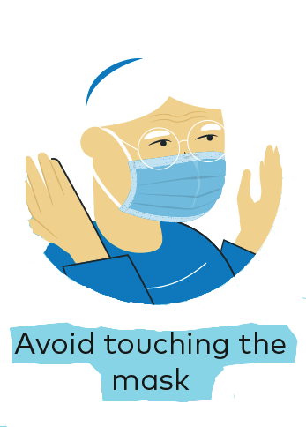

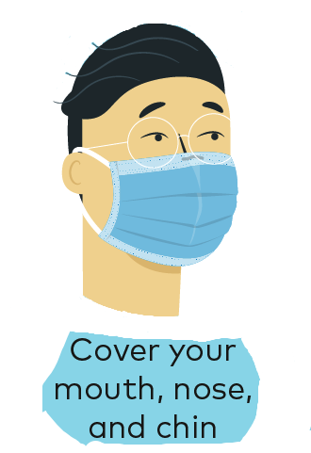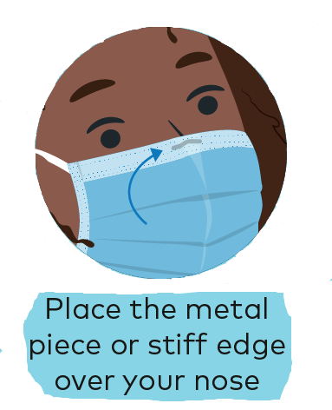**5. 6. 7. 8.**

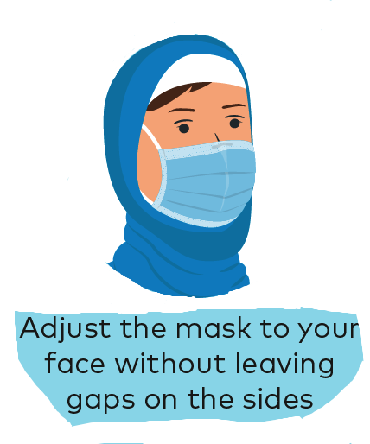

Made by Access Easy English. Australia A3. 18 July 2020. Based on a fact sheet from WHO [https://www.who.int](https://www.who.int/images/default-source/health-topics/coronavirus/masks-infographic---final-(web---rgb).png?sfvrsn=c67232f0_15)

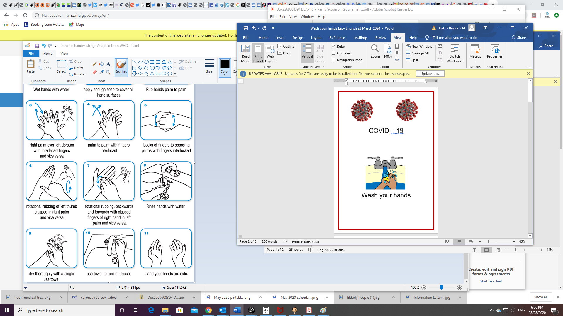



**How to take off a mask** Read the fact sheet

**Wash your hands**

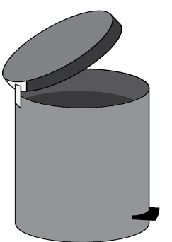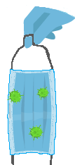

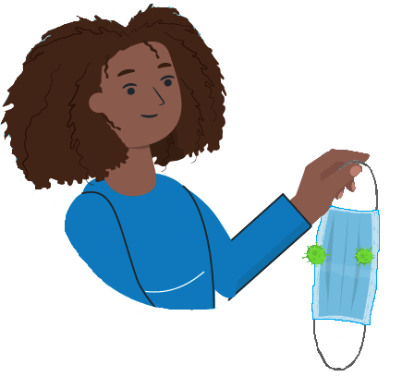**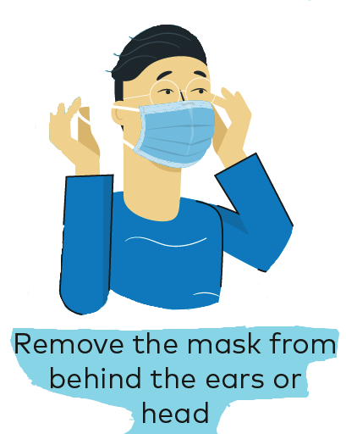****1. 2. 3. 4.**

Made by Access Easy English. Australia A3. 18 July 2020. Based on a fact sheet from WHO [https://www.who.int](https://www.who.int/images/default-source/health-topics/coronavirus/masks-infographic---final-(web---rgb).png?sfvrsn=c67232f0_15) How to wear a medical mask safely. Downloaded 17 July 2020.

Images from EasyOnTheI, Free, Mayer-Johnson, TheNounProject, WHO