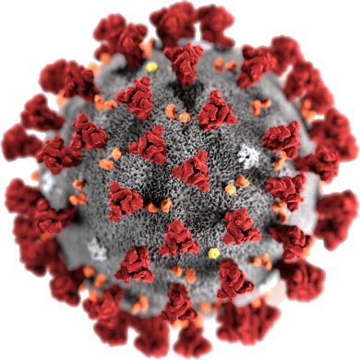

COVID - 19

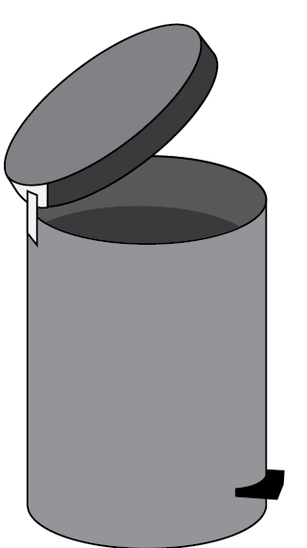
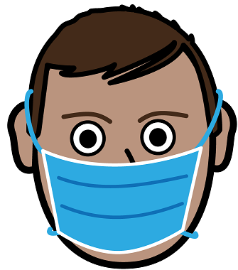
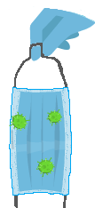

How to use a mask.
You throw this mask away.
21 July 2020
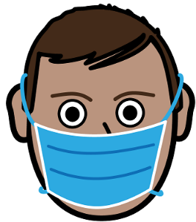
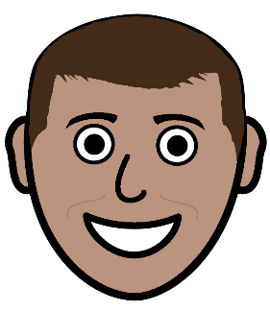
Put on a mask

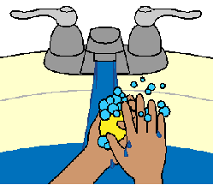

- Wash your hands.

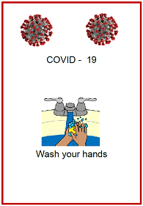

Read the fact sheet
Wash your hands.

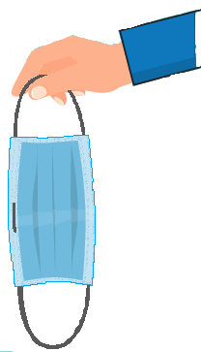
- Pick up a new mask.

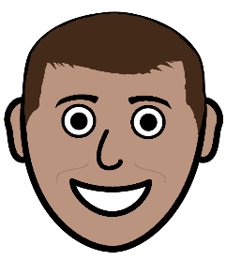
There is a white side. It goes on your face.

There is a blue side. We can all see the blue.

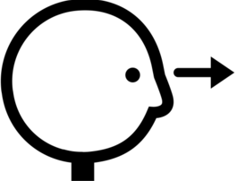
Look at the mask.
There must be no holes in it.
Get a new mask.

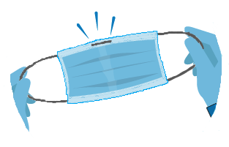
- Find the edge with a metal piece in it.
It feels a bit stiff.
This is the top of your mask.
This edge goes on your nose.

- Put the mask on your face.
The white side is on your face.
We see the blue side.
Put the loops around each ear.

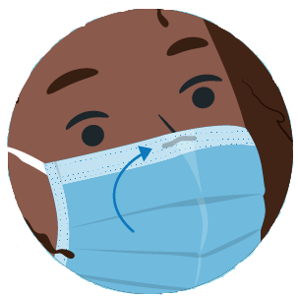
- Feel the metal piece on your nose.
Push it onto your nose.
There must be no gaps here.

- You need to check your mask covers
- your nose
- your mouth.

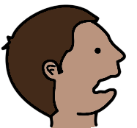

The bottom of your mask goes under your chin.

- There must be no gaps between
- your face
- the mask.
Move your mask so there are no gaps.

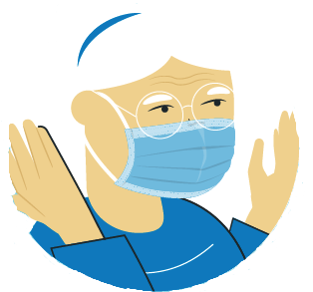
- You are ready to go out.
Do not touch your mask now.

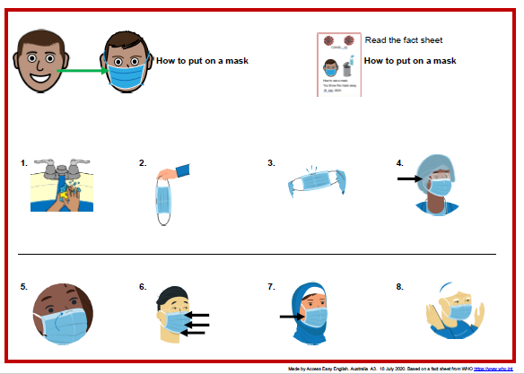
Get the poster. Put it on the wall in
- bathroom
- kitchen
- bedroom
- near the front door.

Take off your mask

- Do not touch the front of your mask.

- Hold on to the loops behind your ears.
Take the loops off your ears.
Your mask comes off your face.

- Do not touch the blue part of your mask.

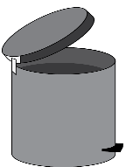

- Put the mask in the bin now.

- Wash your hands.

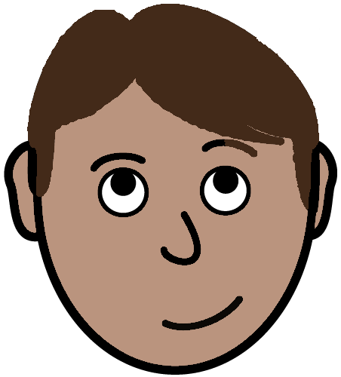
To be safe.
Some things to remember

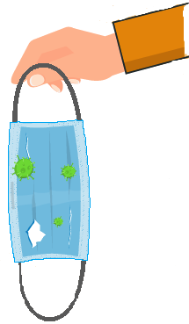
- A mask may get
- wet
- ripped.

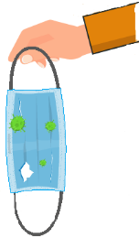

It is no good.

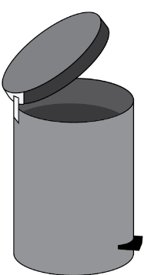
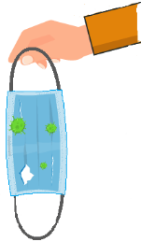

Put it in the bin.
- You mask needs to cover your
- mouth
- nose.

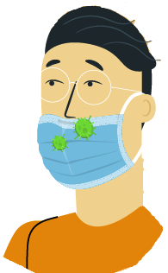

Do not let it fall down. It is no good now.

- Your mask must fit.

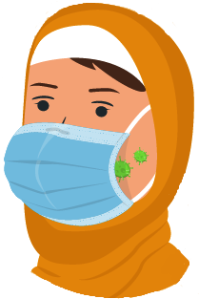

There must be no gaps. It is no good now.

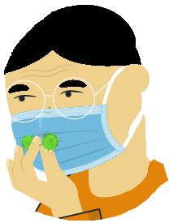
- Do not touch the front of your mask.

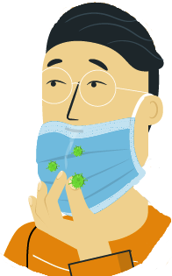
- Do not pull your mask down to
- talk to some one
- to eat.

- Always put a used mask in the bin.

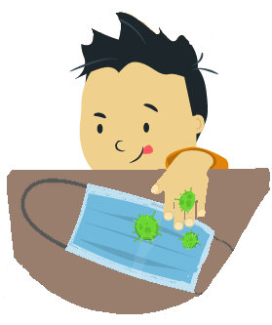
Do not leave your used mask out.
Other people can touch it. This is no good.
- Use a new mask each time you put a mask on.

You can not see bugs on your mask.

But

They are there.
Do not put on a used mask.

Images
We have used images from
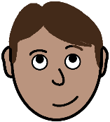
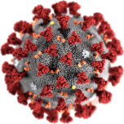
- EasyOnTheI
- Freepikpsd
- Mayer-Johnson
- Picto-Selector
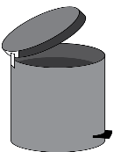
- TheNounProject
- World Health Organisation.

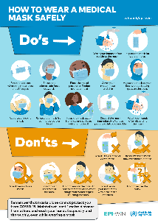
This fact sheet is based on The World Health Organisation How to wear a medical mask safely. www.who.int/epi-win 17 July 2020

Access Easy English wrote the Easy English.
18 July 2020. Updated 21 July 2020.

