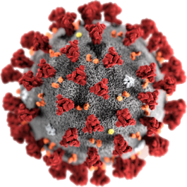

COVID - 19



**What is PPE?**

4 May 2020

**PPE**

It is **Personal Protective Equipment**.

It is the clothes many hospital staff wear now.

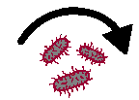

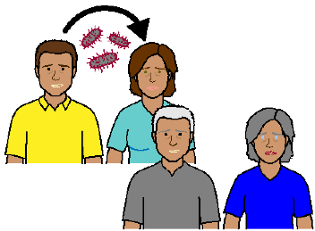

It helps stop people getting COVID - 19. Like

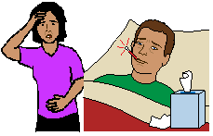

* + - * from some one who may have COVID - 19

**to**

* + - * 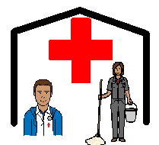the staff in
* hospitals
* 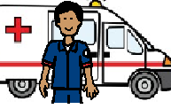nursing homes
* ambulances.

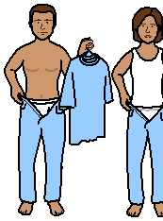**What do they wear?**

**?**

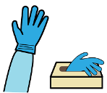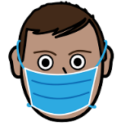

The staff will wear

* + - * gloves
      * a mask

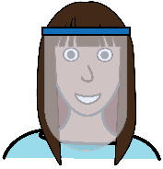

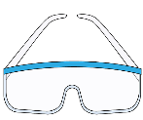

* + - * glasses. Some people wear a full face cover

**and**

* + - * 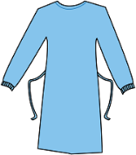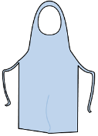a gown
      * an apron



* + - * covers over their shoes.

People can all look the same.



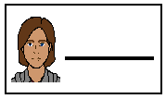

Many staff have on their gown

* + - * their name
      * their photo

**and**

* + - * what they do. Like

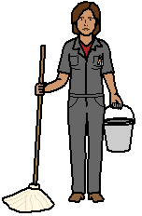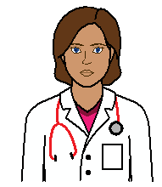

* doctor
* nurse
* cleaner.

**Why do they need to wear PPE?**



It can be easy to get COVID - 19.

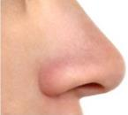It is in tiny tiny drops of stuff from our

* 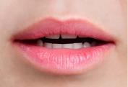nose
* mouth.

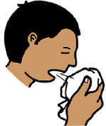We may also get it on our hands when we

* sneeze
* cough
* touch our face.

**Then**



We touch an object.

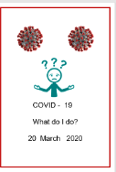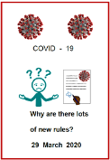Read the fact sheet

* **Look after your self**
* **Why are there lots of new rules.**

COVID - 19 can stay on that object.

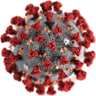

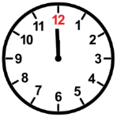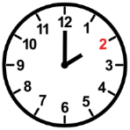Some times it can stay for

* a short time. Like 2 hours

**or**

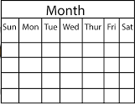

* a long time. Like 3 days.

****They do **not** know how long COID – 19

stays on objects.

**More information**

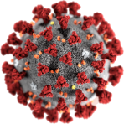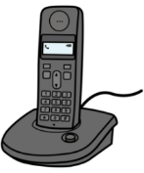

COVID - 19 information. Call 1800 020 080.

You can call at



* 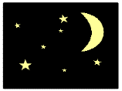any time
* any day.

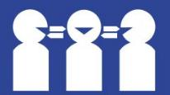Translations

Call 131 450

**Images**

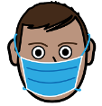We have used images from

* Easy on the I
* Freepikpsd
* Freepik
* 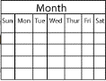****Mayer-Johnson
* Picto-Selector
* SocialBuzz
* TheNounProject.

# This fact sheet is based on www.health.com What is PPE? Everything You Need to Know About Personal Protective Equipment Amid the Coronavirus Outbreak

# 3 April 2020 and

www.safeworkaustralia.com Personal Protective Equipment. 4 May 2020

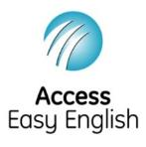Access Easy English wrote the Easy English.

4 May 2020.