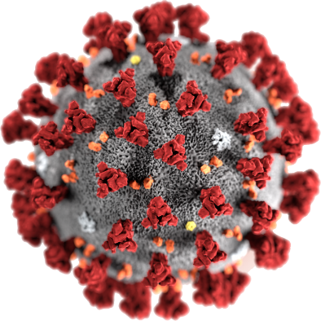

COVID - 19
It is also called Coronavirus.
20 March 2020.

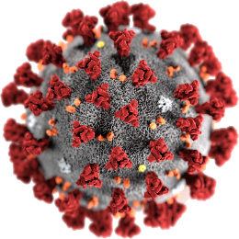
What is COVID - 19?
?

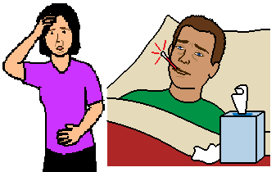

It is an illness. You may get sick.

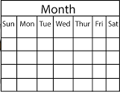
Most people who get sick have been overseas. They came home in the last 2 weeks. Like from
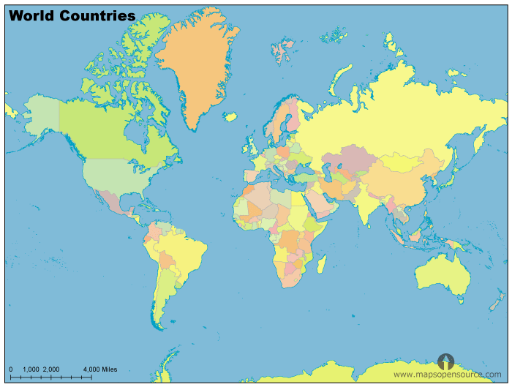
- Europe
- Italy
- Germany
- France
- Spain
- China
- Iran
- South Korea
- United States.
But

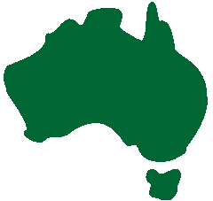
Now
Some people have only been in Australia.
Any one can get COVID - 19

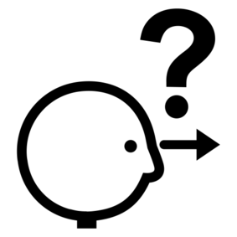
What are the signs of
COVID - 19?

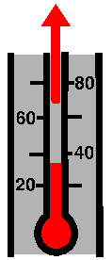
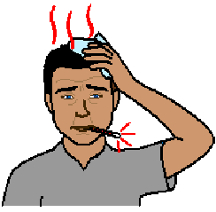
High temperature. It is more than 37C.

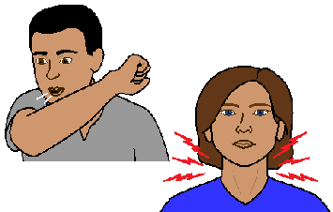
A cough.
Sore throat.

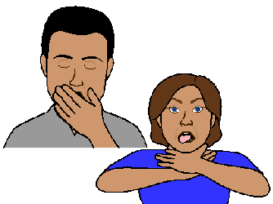
Tired all the time.
Hard to breathe.

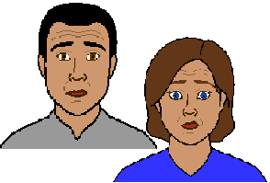
Do I need to worry?
?

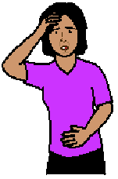

Many people may get sick.

And

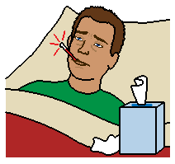
Some people may get very sick.

Read our fact sheet
- Look after your self.

People who may get very sick

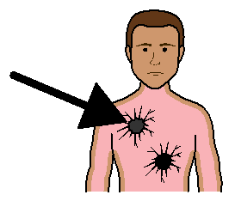

- are already sick. Like you have cancer

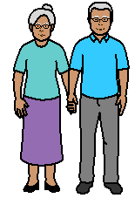
- are old. Like you are more than 60 years old. Older people may get more sick

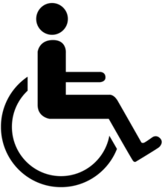
- live with a medical condition. Like
- asthma
- diabetes

Other people who may get very sick are

- people who live in groups. Like
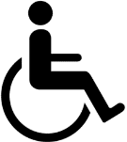
- group home
- nursing home
- prison

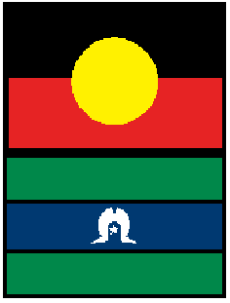
- Aboriginal

- Torres Strait Islander people

Read our other fact sheets
- Look after your self
- Rules in nursing homes.

Images
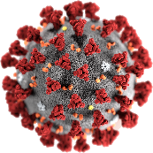
We have used images from
- Freepikpsd
- MapsOpenSource
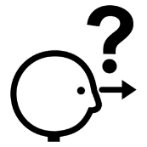
- Mayer-Johnson
- Picto-Selector

This fact sheet is based on
The Australian Government Health Department Novel Coronavirus (COVID - 19) 17 03 2020

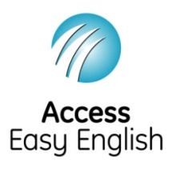
Access Easy English wrote the Easy English. March 2020.

