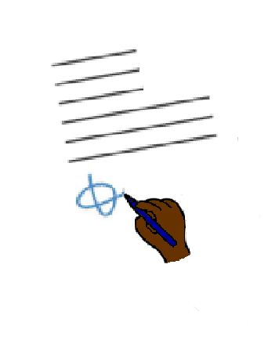COVID - 19

New rule. We need space between us

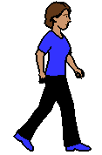



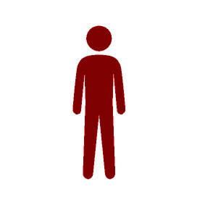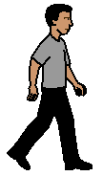





**Inside and outside**

**Be 2 steps away from other people**

* **behind you**
* **in front of you**
* **beside you.**

Made by Access Easy English. Version 1. Updated 24 March 2020