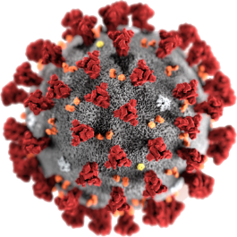

COVID - 19
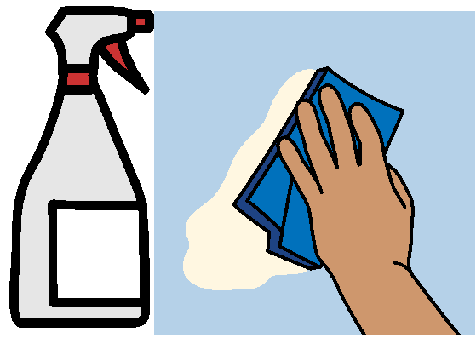

Time to clean
5 April 2020

This fact sheet will tell you
- why we need to wipe every where
- ideas for places to wipe.

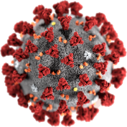
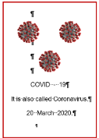
What is COVID - 19?
Read the fact sheet What is COVID - 19?

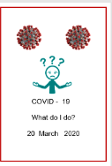
How can I look after my self?
Read the fact sheet Look after your self

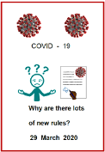
Why are there lots of new rules?
Read the fact sheet
Why are there lots of new rules?
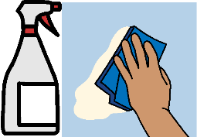
Time to clean

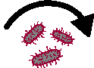
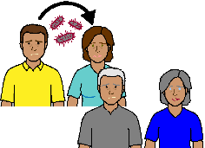
It can be easy to get COVID - 19.

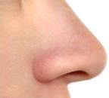
It is in tiny tiny drops of stuff from our
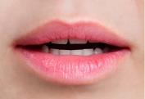
- nose
- mouth.

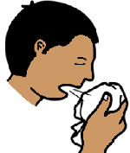
We may also get it on our hands when we
- sneeze
- cough
- touch our face.

Then
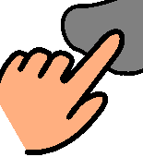

We touch an object.

Read the fact sheet
- Look after your self
- Why are there lots of new rules.

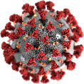
COVID - 19 can stay on that object.

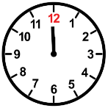
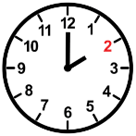
Some times it can stay for
- a short time. Like 2 hours

or
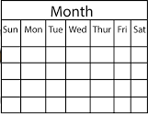

- a long time. Like 3 days.

They do not know how long COID – 19
stays on objects.

They want us to clean things we touch.
And
Clean things that other people touch.

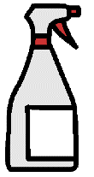
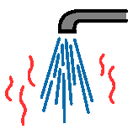
They say use
- cleaning detergent
and
- warm water.

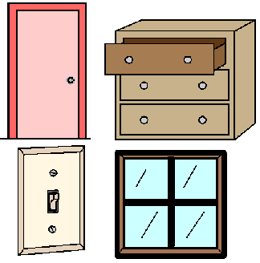
At home you need to clean
- doors
- drawers
- windows
- light switches
and
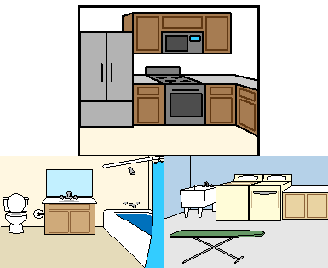
Many things in your
- kitchen
- bathroom
- toilet

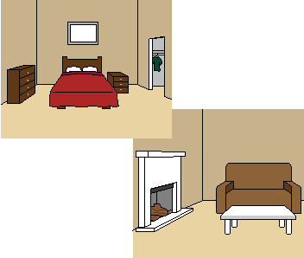
- bedroom
- living room.

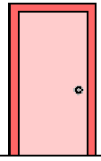
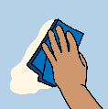
Doors
Clean the door handles.
But
many people touch other parts of the door.
Like
- above the door handle
- below the door handle.
You need to clean all these places too.

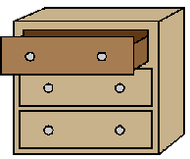
Drawers
Clean the drawer handle.
Look where people
- pull the drawer
or
- push the drawer.

They may put their hand under the drawer.
Their fingers are on the front of the drawer,
or
They may put their hand into the top of the drawer. It pulls the drawer out.
All these places need to be cleaned.

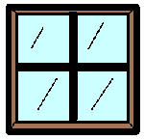
Windows
Clean where you open the window. Like
You put your hands
- on the glass
or
- at the bottom of the window frame
or
- the top of the window.

You may have a window winder.
You may have an edge to pull.

Clean where you open the window.

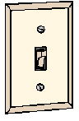
Switches. Like
      - heater switch
      - light switch.

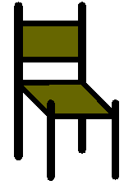
Chairs. Like kitchen chairs
Clean the
- back of the chair. You may put your hand here to pull a chair out.
- sides of the chair. You may put your hands here when you pull a chair in.

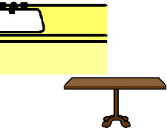
Tables and Benches
Wipe the top.
Clean the side edges.
Clean under the edge.
People may put their fingers here too.
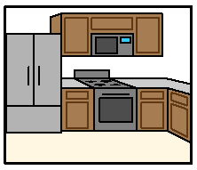
Kitchen
Look at all the things different people use.

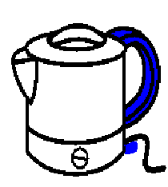
Many things may stay out on your benches. Like
- kettle
- on switch
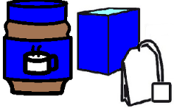
- handle
- coffee jars. Tea jars. sugar bowl

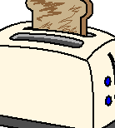
- toaster
- on button
- push down to cook button
- stop button
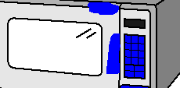
- microwave
- all the settings
- on button
- door opener.
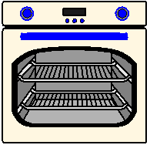
- oven
- all the switches
- door opener.

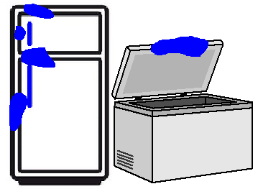
- fridge. Where people open and close it
- freezer. Where people open and close it

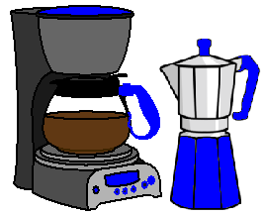
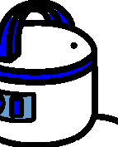
- coffee machine
- rice cooker

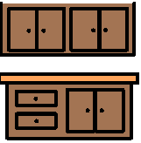
- kitchen benches
- cupboards
- drawers.

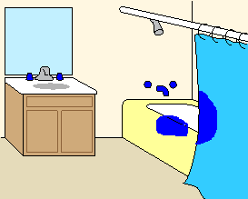
Bathroom
Taps in
      - shower
      - basin
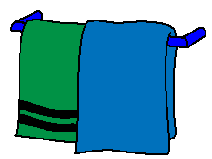
Shower where you open the door
Towel rails.

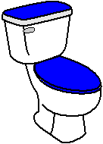
Toilet
Flush button
Seat
Toilet Lid

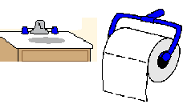
Basin taps.
Toilet paper holder.

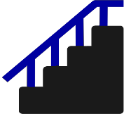
Other things
Handrails on stairs.

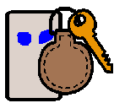
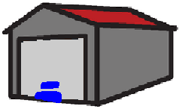
Garage door handle or automatic opener.

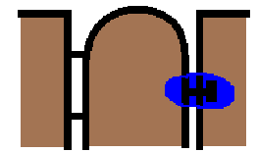
Gate handles.

Write down other places you need to clean.
___________________________________________________________________________________________________________________________________________________________________________________________________
Other things to clean
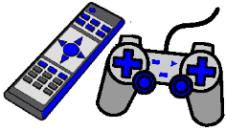
Ipad.
TV remote controls.
Xbox remotes.

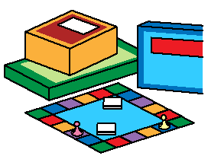
Plastic pieces to games.
Wipe down the board of the game.

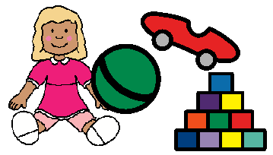
Children toys. Like
- dolls
- lego and blocks
- plastic toys.

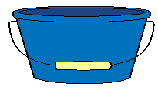
Make it a game with your children.
Fill a dish with warm water and soap.
Help them to wash their toys.
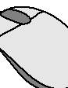
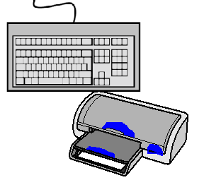
Some more things to clean
Keyboard on your computer.
Buttons on your printer.
Computer mouse.

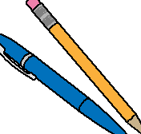

Each person has their own pens.

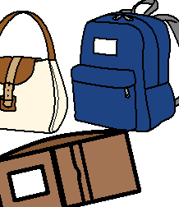
Handbag.
School bag.
Wallet.

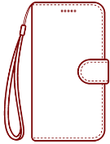
Phone cover.
Phone.
Write down other things you share.
You need to clean them.
____________________________________________________________________________________________________________________________________________________________________________________________________________________________________________________________________________________________________________________________________________________________________________________________________________________________________________________________________________________

More information

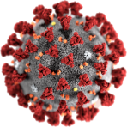
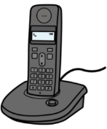
COVID - 19 information. Call 1800 020 080.

You can call at
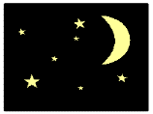
- any time
- any day.

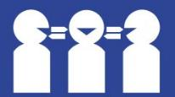
Translations
Call 131 450

Images
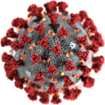
We have used images from
- Freepikpsd
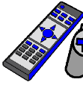
- Inspired Services
- Mayer-Johnson
- Picto-Selector
- TheNounProject.

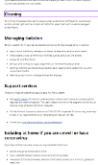
This fact sheet is based on the Australian Government Health Department

What you need to know. 17 March 2020.

Access Easy English wrote the Easy English.
5 April 2020.

